Some Related Info
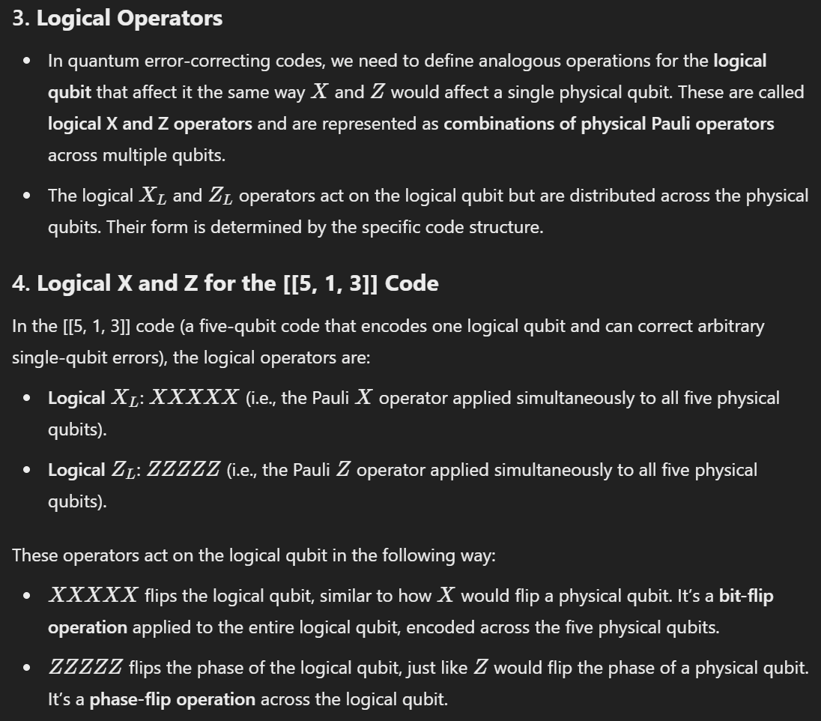

Steane Code Logical Qubits
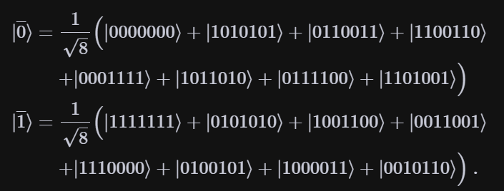
Modified FiveQubitCode_aux.cpp accordingly.


